

**INTERNATIONAL SCHOOL**

**GROUP PROJECT 1**

**CMU-CS 246 TIS**

**USER INTERFACE DESIGN DOCUMENT**

Version: 2.0

**SIMPLE CALCULATOR APPLICATION**

**Mentor: Nguyen Dang Quang Huy**

***Team Member*:**

Ly, Huynh Thi

Khoa, Tra Van Minh

Nhu, Tran Thi

Yen, Vo Thi Nhu

Vy, Vo Tran Khanh

**Approved by Huy Nguyen Dang Quang**

**UserInterface Review Panel Representative:**

Name Signature Date

**GROUP PROJECT 1- Mentor:**

Name Signature Date

Da Nang, 03/2025

**PROJECT INFORMATION**

|  |  |
| --- | --- |
| **Project Acronym** | FMS |
| **Project Title** | Food Management System | | | |
| **Start Date** | 3 – Mar–2022 | **End Date** | 3 – Mar –2022 | |
| **Lead Institution** | International School, Duy Tan University | | | |
| **Team Member** | **Name** | **Email** | | **Phone** |
| 29209020282 | Huynh Thi Ly | huynhthily.021225@gmail.com | | 0987083753 |
| 29219054767 | Tra Van Minh Khoa | minhkhoa131103@gmail.com | | 0702665686 |
| 29201135555 | Tran Thi Nhu | Nhuchinhdep2512@gmail.com | | 0846675009 |
| 27201201584 | Vo Thi Nhu Yen | Vothinhuyen22042003@gmail.com | | 0848822072 |
| 29209043512 | Vo Tran Khanh Vy | Khanhvyken50@gmail.com | | 0935189177 |

**PROJECT PLAN DOCUMENT**

|  |  |  |  |
| --- | --- | --- | --- |
| **Document Title** | User Interface Document | | |
| **Author(s)** | Team 6 | | |
| **Date** | Mar 07th, 2025 | **File name:** | USER INTERFACE DESIGN DOCUMENT |
| **URL** | https://drive.google.com/drive/folders/1fGKJPGugGFOSmfwBxRWSI3Tr8TCBsG1R?usp=sharing | | |
| **Access** | Project and CMU Program | | |

**SIGNATURE**

**Document Approvals:** The following signatures are required for approval of this document.

|  |  |  |  |
| --- | --- | --- | --- |
| **Mentor** | Huy, Nguyen Dang Quang | **Signature:** |  |
| **Date:** |  |
| **Scrum master** | Ly, Huynh Thi | **Signature:** |  |
| **Date:** |  |
| **Team member(s)** | Khoa, Tra Van Minh | **Signature:** |  |
| **Date:** |  |
| Nhu, Tran Thi | **Signature:** |  |
| **Date:** |  |
| Yen, Vo Thi Nhu | **Signature:** |  |
| **Date:** |  |
| Vy, Vo Tran Khanh | **Signature:** |  |
| **Date:** |  |

**DOCUMENT HISTORY**

|  |  |  |  |
| --- | --- | --- | --- |
| **Version** | **Person** | **Date** | **Description** |
| 1.0 | Vy, Vo Tran Khanh | Mar 27th, 2025 | Draft |
| 2.0 | Vy, Vo Tran Khanh | Apr 19th, 2025 | Draft |

**Mục Lục**

**I.** **INTRODUCTION** 6

**1.** **PURPOSE** 6

**3.** **AUDIENCE** 6

**II.** **LIST OF USER INTERFACE** 6

**1.** **BUSINESS FUNCTION DIAGRAM:** 6

**2.** **Web App** 7

**III.** **DESCRIBE USER INTERFACE** 8

**1.** **CALCULATOR INTERFACE** 8

1. **INTRODUCTION**
2. **PURPOSE**

* Document the design of the user interface for the functions of the Calculator Application.
* Be the primary document driving the implementation of the user interfaces.
* Introduce interface design for the reader, including background, content information display, and command buttons.

1. **SCOPE**

* This document helps to better understand the interface of the Calculator Application, detailing specification components and functions of the system.
* With this document, the development team can understand the structure and composition to create a consistent and complete application.
* Overview of the stages and modules of the software to create a fully functional interface.

1. **AUDIENCE**

This document is intended for the following audiences:

* **Technical reviewers**, including:
  + Scrum Master
  + Product Owner
* **Implementers**, including:
  + Developers
  + Testers

1. **LIST OF USER INTERFACE**
2. **BUSINESS FUNCTION DIAGRAM:**

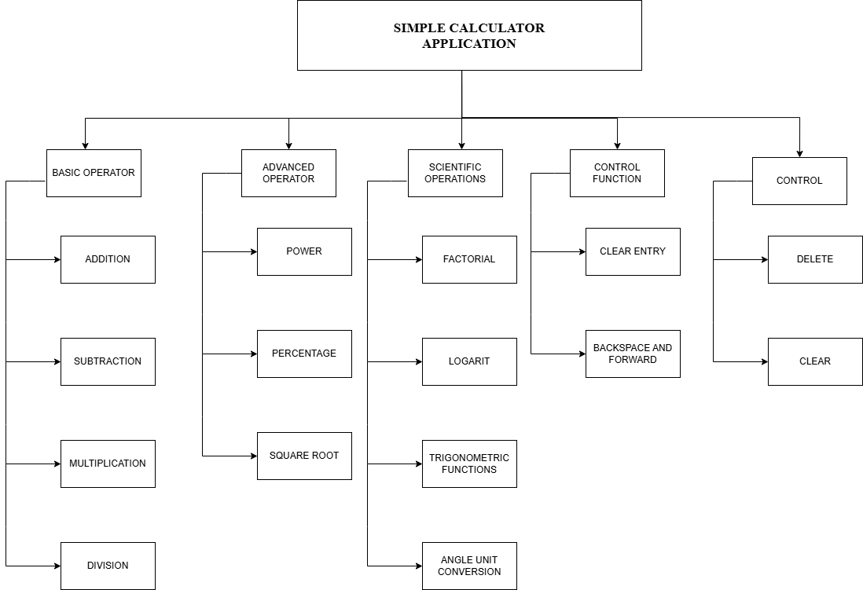

1. **Web App**

|  |  |  |
| --- | --- | --- |
| **User Interface ID** | **UI Name** | **Description** |
| UI-01 | Calculator Main Page | This page provides the main calculator interface where users can perform arithmetic and advanced operations. |
| UI-02 | Basic Operations Page | This page allows users to perform addition, subtraction, multiplication, and division. |
| UI-03 | Advanced Operations Page | This page provides additional functionalities such as exponentiation, square root, and percentage calculations. |
| UI-04 | Memory Functions Page | This page enables users to store, recall, and clear stored values. |
| UI-05 | History Page | This page displays a log of previous calculations in the current session. |
| UI-06 | Settings Page | This page allows users to customize calculator settings, such as precision and theme. |
| UI-07 | Clear & Refresh Page | This page provides options to clear input or refresh the session. |
| UI-08 | Factorial (n!) | Adds the functionality to calculate the factorial of a number (n!). |
| UI-09 | Logarithm Functions | Adds buttons for logarithmic calculations: log₁₀(x) and ln(x). |
| UI-10 | Trigonometric Functions | Adds buttons for trigonometric functions: sin(x), cos(x), tan(x), and cot(x). |
| UI-11 | Angle Unit Conversion | Adds functionality for converting between degrees and radians. |
| UI-12 | Clear Entry (CE) Button | Adds a button to clear the current entry without affecting the entire calculation. |
| UI-13 | Backspace (←) and Forward (→) | Adds buttons for backspace (←) to delete the last character and forward (→) to restore or add back the last deleted character. |

1. **DESCRIBE USER INTERFACE**
2. **CALCULATOR INTERFACE**

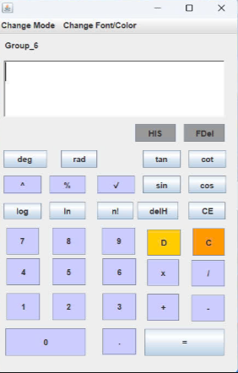

|  |  |  |  |
| --- | --- | --- | --- |
| **ID** | **Condition** | **Control Type** | **Target** |
| 1 | Press | Input text | Display input and calculation results |
| 2 | Press | Button | Power function (x^y) |
| 3 | Press | Button | Square root function (√) |
| 4 | Press | Button | Percentage function (%) |
| 5 | Press | Button | Memory Recall (MR) |
| 6 | Press | Button | Memory Add (M+) |
| 7 | Press | Button | Memory Subtract (M-) |
| 8 | Press | Button | Delete last input (DEL) |
| 9 | Press | Button | Clear all input (C) |
| 10 | Press | Button | Digits 0-9 for number input |
| 11 | Press | Button | Arithmetic operations (+, -, *, /) |
| 12 | Press | Button | Equals button (=) to execute calculations |
| 13 | Press | Button | Decimal point (.) for floating-point calculations |
| 14 | Press | Button | Factorial (n!) to calculate the factorial of a number |
| 15 | Press | Button | |  | | --- | |  |  |  | | --- | | Logarithm (log₁₀(x)) to calculate the base 10 logarithm of a number | |
| 16 | Press | Button | |  | | --- | |  |  |  | | --- | | Natural Logarithm (ln(x)) to calculate the natural logarithm of a number | |
| 17 | Press | Button | Trigonometric functions: sin(x), cos(x), tan(x), cot(x) |
| 18 | Press | Button | Angle unit conversion: Degrees ↔ Radians |
| 19 | Press | Button | Clear Entry (CE) to delete the current entry without affecting the calculation |
| 20 | Press | Button | Backspace (←) to delete the last character input |
| 21 | Press | Button | |  | | --- | |  |  |  | | --- | | Forward (→) to restore or add back the last deleted character | |